A04: AI in Fraud Detection Case Study

ITAI-2372- Artificial Intel Applications

November 5, 2024

Team 9

Houston Community College

**The use of Artificial Intelligence for Fraud Detection at JPMorgan Chase**

**Introduction**

Banking institutions are on a race with fraudsters and money launderers to create barriers to avoid cybercriminal activities against banking systems. The cost of traditional fraud detection methods is estimated to be trillions of dollars annually. Traditional fraud detection methods, which typically are rule-based and dependent on manual review, struggle to keep pace with the evolving tactics of cybercriminals. In fact, global credit card fraud losses hit $32 billion in 2020, with the U.S. responsible for over a third of those losses, and 74% of organizations reported being targets of payment fraud.

JPMorgan Chase is one of the most important U.S. financial institutions in US based in New York City, and it has become a leader in adopting artificial intelligence (AI) for fraud detection. The bank has millions of customers worldwide, which brings a significant risk of financial fraud, especially as digital transactions and online banking grow.

In its effort to prevent fraud, JPMorgan has turned into AI-driven solutions to analyze trends, pinpoint suspicious activity, and ultimately improve fraud detection accuracy. Since AI is capable of analyzing massive quantities of data in real-time, it has proven essential in detecting fraud early, reducing the number of false positives, and maintaining the trust of customers by securing their accounts.

**Technology Overview**

JPMorgan Chase implemented an advanced AI model that uses machine learning algorithms for fraud detection. This model analyzes transaction data to identify anomalies and high-risk transactions using historical data. The AI model uses a behavioral approach, where the system evaluates user interactions and identifies unusual activity patterns through a graph-based framework. The AI system is set to establish complex networks of interactions, recognize deviations from normal behavior, and flag these for further investigation. At the same time, the system has the ability to learn over time with every new transaction such that it increases the accuracy and reduce false positives (this indicates a valid transaction mistakenly flagged as fraudulent). The diagram below shows the most common components of an AI system for fraud detection. JP Morgan Chase integrated this AI model into its fraud detection framework to alert customers for potential fraudulent transactions.

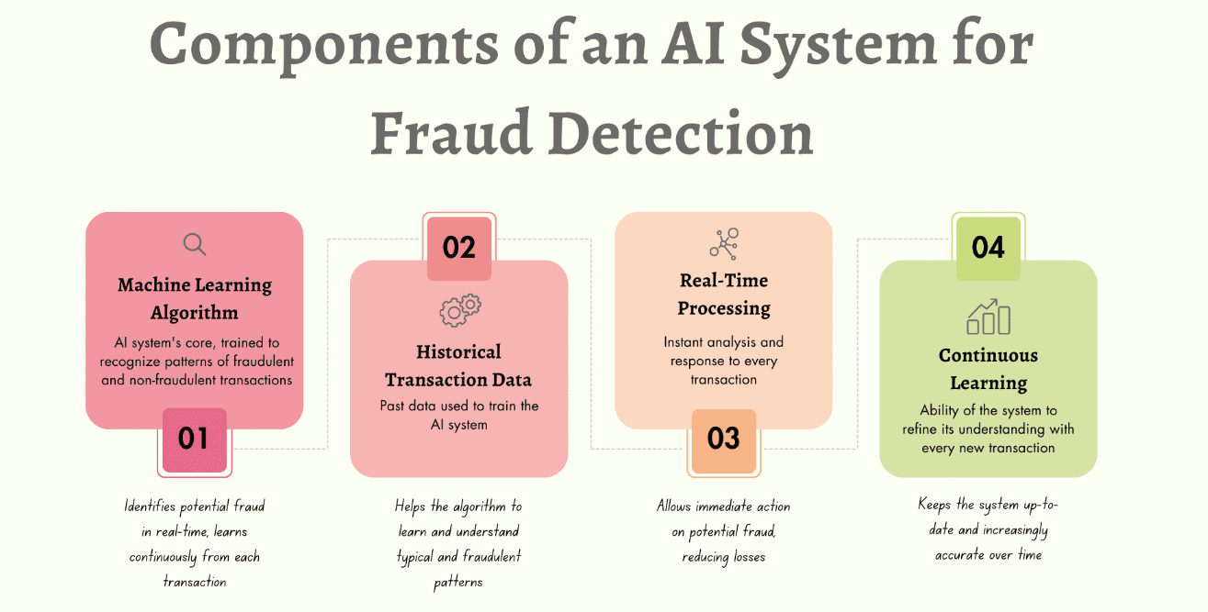

**Benefits**

The implementation of AI for fraud detection at JPMorgan Chase has significantly improved fraud detection:

* Reduction in False Positives: JPMorgan has achieved a 50% reduction in false positives in overall fraud detection and a 95% reduction in false positives specifically of anti-money laundering activities.
* Improved Efficiency and Real-Time Monitoring: JPMorgan’s fraud detection system can monitor transactions in real-time, allowing for faster detection of suspicious activities with greater accuracy.
* Cost Savings: Reducing false positives has helped JPMorgan to cut down operational costs and minimize the impact on customer experience. Lower false positives reduce unnecessary alerts, saving resources that would otherwise be spent on investigating non-fraudulent transactions.
* Improved Customer Trust: The enhanced AI system has increased customer trust in JPMorgan Chase by reducing false positives and enhancing security.

**Challenges**

While the integration of AI in fraud detection has been beneficial, JPMorgan faced several challenges:

* **Protecting Data Privacy and Security**: A critical challenge in adopting AI for fraud detection at JPMorgan is ensuring the privacy and security of customer data. Since the system depends on analyzing customer transaction data to spot fraudulent activities, it is essential to maintain strict safeguards. To address this, JPMorgan implemented advanced encryption techniques and complied with strict data protection standards to secure sensitive information. These measures not only safeguard customer privacy but also support regulatory compliance and foster trust in the bank's AI-driven fraud detection capabilities.
* **Building Internal Support**: Securing buy-in from stakeholders and employees was another hurdle. Initially, some employees were cautious about relying on AI over traditional methods for fraud detection. JPMorgan responded by organizing comprehensive training sessions to educate employees on AI’s role and value. Additionally, they conducted pilot programs that showcased the AI system’s effectiveness in real scenarios, demonstrating the tool’s reliability. This approach helped build confidence and encouraged a broader acceptance of AI within the organization.
* **Ensuring Ongoing Improvement**: Financial fraud methods evolve quickly, making it essential for JPMorgan’s AI system to stay current and adaptable. The bank has invested significantly in ongoing research and development to regularly update and refine its AI model. This commitment to continual improvement keeps the bank’s fraud detection technology effective, enabling it to keep pace with emerging fraud techniques and enhance its precision over time.

**Conclusion**

JPMorgan Chase’s integration of Artificial Intelligence for fraud detection exemplifies how cutting edge technology can transform financial security practices in a rapidly evolving digital landscape. Traditional methods of fraud detection have struggled to keep up with sophisticated cyber threats, yet AI-driven systems now offer the agility and precision needed to safeguard customers and institutions alike. By reducing false positives by up to 95% in anti-money laundering detection and enabling real time monitoring. JPMorgan’s AI model not only streamlines operations but also reinforces customer trust, demonstrating a commitment to both security and efficiency.

Implementing this technology however did come with notable challenges. Ensuring data privacy, gaining organizational buy-in, and committing to ongoing system improvements were all critical factors in the successful adoption of AI. By prioritizing data security through advanced encryption, educating employees on the value of AI, and conducting real world pilot programs, JPMorgan was able to manifest internal and external credibility. Additionally, the bank’s dedication to refining its AI model has allowed it to stay current and responsive to emerging fraud techniques. The defenses remain robust because of it.

JPMorgan’s advancements with AI powered fraud detection emphasizes a broader industry shift toward technology driven security. As other financial institutions look to this model, the banking industry is poised to adopt AI as a sustainable and scalable solution to combat fraud. By setting new standards for accuracy, efficiency, and adaptability; JPMorgan not only strengthens its own security posture but also contributes to a safer financial landscape for customers and organizations worldwide.

**References**

* Needhi, Jeyadev. (2024, July 7). How AI Transformed Financial Fraud Detection: A Case Study of JP Morgan Chase. *Medium*. <https://medium.com/@jeyadev_needhi/how-ai-transformed-financial-fraud-detection-a-case-study-of-jp-morgan-chase-f92bbb0707bb#:~:text=Improved%20Fraud%20Detection&text=The%20AI%20system%20can%20identify,effectively%E2%80%8B%E2%80%8B%E2%80%8B%E2%80%8B>.
* AI.business. (2024, March 26). 95% Fewer False Alarms: JPMorgan Chase Uses AI to Sharpen Anti-Money Laundering Efforts. *AI.business* <https://ai.business/case-studies/ai-to-improve-anti-money-laundering-procedures/>.
* Rabata, Rasheed. (2023, July 2). Detecting Fraud in Real-Time: How a Financial Institution Used AI. *capella*. <https://www.capellasolutions.com/blog/detecting-fraud-in-real-time-how-a-financial-institution-leveraged-ai>s.